 | Karan Builders | Document No: | KB-EHS-CHE-18
 |  | Rev No: | 00
 |  | Date: | 01.01.2022
LIFTING TOOLS & TACKLES

Name of Project: Contractor Name:-
Sr.No:- Date:-

Equipment Name & Number: |  | LIFTING TOOLS & TACKLES
Note: Please write Yes or No in the given box and if some comments write in remarks column.
SN. | Description |  | Yes/No | Remarks
1. | Wire sling should be free from defects, e.g., corrosion, crack, cuts & oily, etc.
2. | Use thimble for making I-shape.
3. | Wire rope should be knotted with proper clamp.
4. | Web sling should be free from defects, e.g., cuts, abrasion, knot, hole & oily, etc.
5. | I-shape should be free from damages.
6. | D-shackle should be in good condition and its face should not expand more than 15% of its original  shape.
7. | Suitable I-bolt should be used.
8. | Lifting tools & tackles should be used having suitable strength & capacity.
9. | Lifting tools & tackles should be handle and store in safe manner.

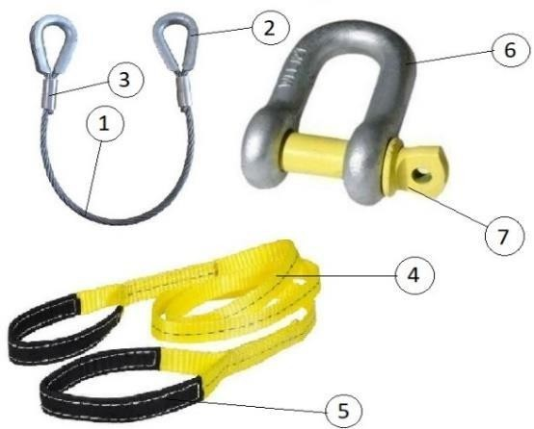

 | NAME | SIGNATURE BY | DATE
Checked by Supervisor
Checked by P & M Incharge
Verified by EHS Officer

Prepared By | Reviewed By | Approved By

